Configure The Application To Receive The Data From Cloud

|  |  |
| --- | --- |
| Team Id | PNT2022TMID01003 |
| Title | Hazardous Area Monitoring for Industrial Plant using IoT |

Node red flow created to get values

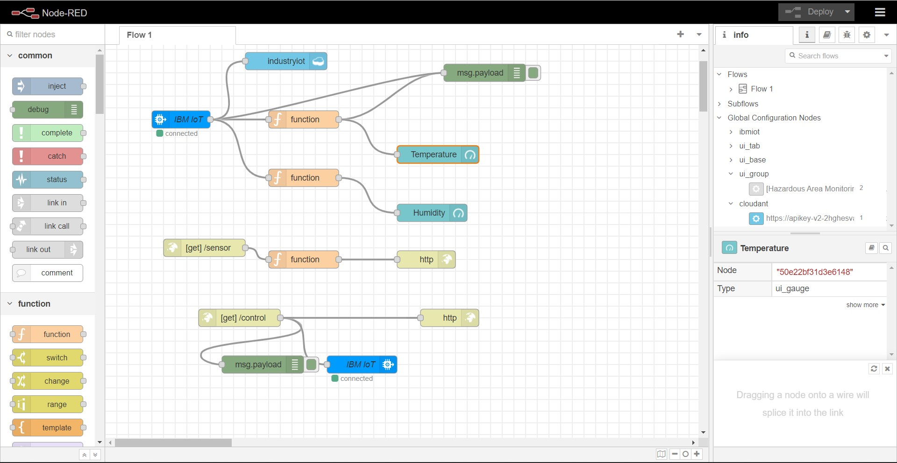

Configuring function to fetch the desired value

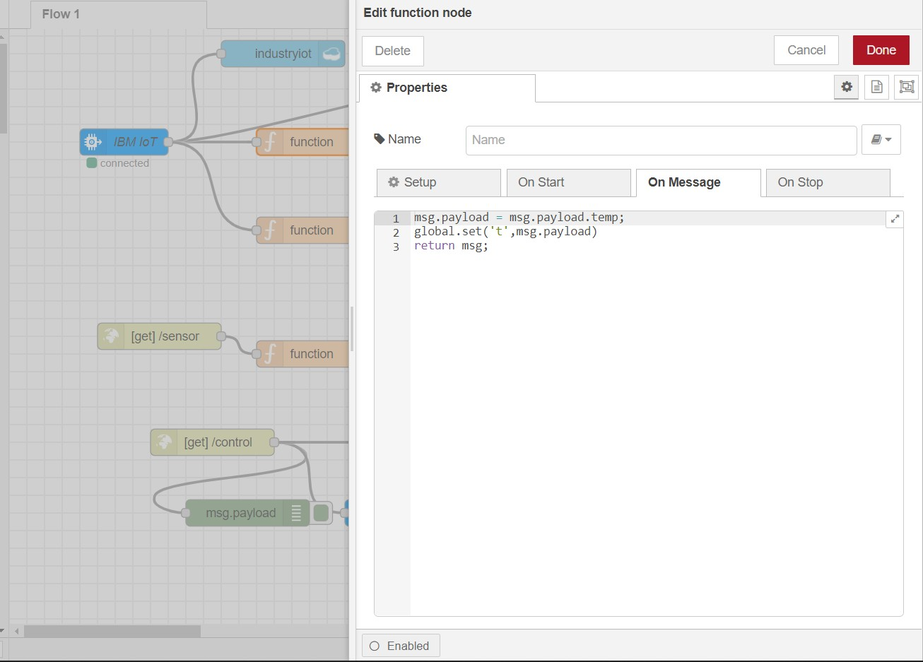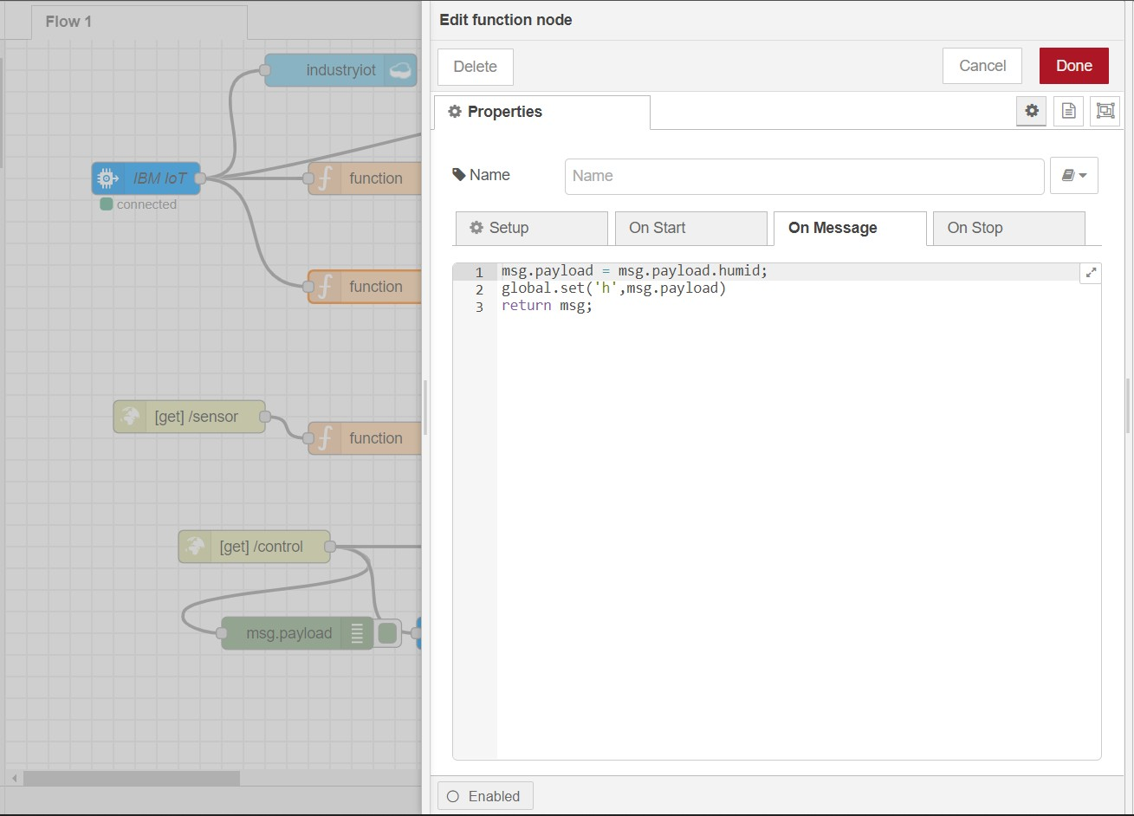

App Blocks to render the values and display it in app

